Local Literacy Plan

for

Golden Meadow Lower Elementary

Kelly Adams, Principal

Jarod Martin, Superintendent

May 23, 2024, Completion Date

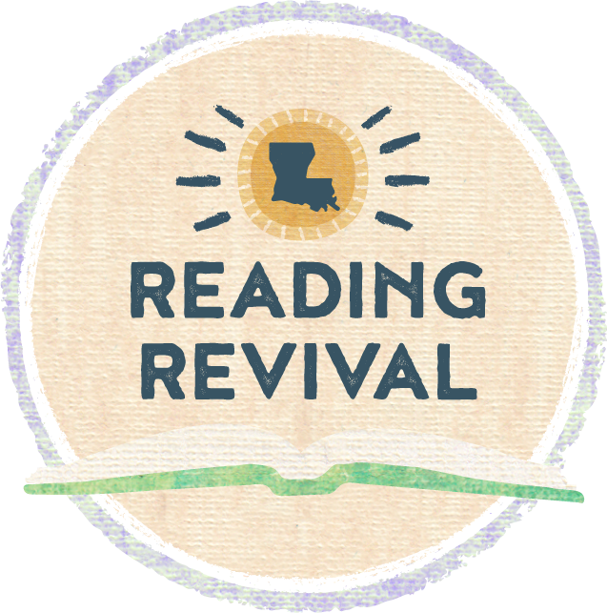

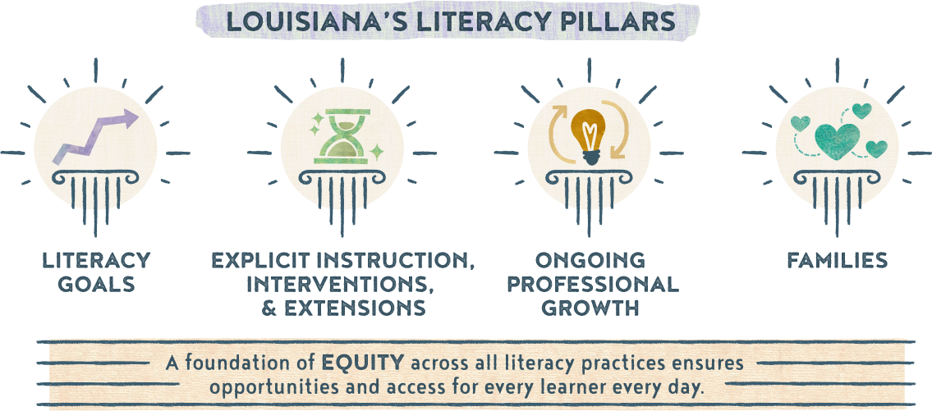

Section 1a: Literacy Vision and Mission Statement
Guiding Questions:
- What is your school/system’s focus and mindset around literacy?
- What is your primary, overarching goal and expected or intended outcomes for your school(s) around literacy?
- Is your vision and mission statement inclusive of all leaders, teachers, students, and families?

Literacy Vision | To develop, implement, monitor, and sustain a literacy initiative utilizing Tier I Curriculum, Literacy Professional Development, and Early Literacy Assessments aligned to the Science of Reading.
Literacy Mission Statement | Every student will develop and demonstrate effective reading, writing, speaking, and listening skills by participating in high quality, explicit literacy instruction across all content areas.

Section 1b: Goals
Guiding Questions:
- What are your overall literacy goals?
- Are you creating SMART goals for grade bands, subgroups, diverse learners, and teachers?
    - How are you measuring the performance of birth through grade 12?
    - What subgroups are most in need of literacy intervention?
    - How are you addressing the literacy and language needs of diverse learners?
    - How do you plan to measure teacher performance based on your literacy goals?
Goal 1 (Student-Focused) | Students will read on grade level or show adequate progress by the end of the school year.
Goal 2 (Teacher-Focused) | 100% of students meet individualized growth goals on literacy benchmarks.
Goal 3 (Program-Focused) | Improve overall reading proficiency of K-5 students as measured by the DIBELS 8 literacy assessment.

Section 1c: Literacy Team
Guiding Questions:
- Who will serve on the school/system literacy team?
- What is the role of each member?
- What is your plan for conducting regular meetings, including location, time, availability, and topics?
- How are you monitoring the effectiveness of the plan?
Member | Role
School Administrator | Program Support
Teachers (Regular Ed, Special Ed, Interventionist) | Program Implementation
Curriculum Coaches | Program Development/Support
Family Members | Program Support
Students | Program Implementation
Paraprofessional | Program Implementation/Support
Students | Program Implementation

Meeting Schedules

Date & Type of Meeting (Plan Review, Data Analysis, etc.) | Frequency of Meetings (Weekly, Monthly, etc.) | Topic(s)
Leadership Meeting | Monthly | CKLA Curriculum, Data, CDAs, NIET Best Practices
PLCs | Weekly | CKLA Curriculum, Data, CDAs, NIET Best Practices
Family Engagement Activities | Each 9 weeks | Share reading strategies and activities
Success Criteria
What are we doing? | Why are we doing it? | How will we know it worked?
CKLA | Tier I Curriculum | CDAs
mClass/DIBELS 8/Amplify Reading | Tier II Support | DIBELS Progress Monitoring
TS GOLD/DIBELS 8 | Universal Screens | Benchmark Data
NIET Best Practices | School Improvement | NIET Walk-through Support
Sonday/Project Read/Read Well/Burst Lessons | Tier III Support | DIBELS Progress Monitoring
Curriculum Coaches | School-Level Literacy Support | NIET Walk-through Support

Section 2: Explicit Instruction, Interventions, and Extensions
Guiding Questions:
- For each specific plan and activity around literacy, what is/are your:
    - action steps?
    - timeline?
    - person(s) responsible?
    - resources?
    - alignment to literacy goal(s)?
    - evidence of success?
- When implementing literacy curriculum and assessments, how are you ensuring:
    - alignment to current research on foundations of reading and language and literacy?
    - cultural responsiveness?
    - connections across content areas?
- When utilizing literacy screeners, what are your plans for:
    - deciding which components will be measured in each grade band or subgroup?
    - how often screeners are administered?
    - progress monitoring?
    - screening and supporting students in upper grades effectively?
- When planning for and providing literacy interventions for struggling readers and writers, are you including specifications for:
    - students with dyslexia?
    - the EL population?
    - special education students?
    - cultural and dialectical sensitivity?

The action plan table on the next page can be used to plan out specific action steps related to literacy goals.

Action Plan

Goal | Timeline | Action Steps | Person(s) Responsible | Resources | Evidence of Success
Improve overall reading proficiency of K-2 students as measured by the DIBELS 8 literacy assessments | Ongoing | Implement Tier 1 Curriculum | Principals and Coaches | CKLA  Amplify Reading  MClass-literacy interventions for struggling readers | CDAs  DIBELS Progress Monitoring  Observation/Feedback
100% of students meet individualized growth goals on literacy benchmarks. | Ongoing | Implement Tier I Curriculum  Classroom small groups  Amplify Reading  mClass Activities  PLCs with reading curriculum focus aligned to Science of Reading | Administration, Teachers, Coaches, interventionist, SpEd Teachers | CKLA – Annotated lessons  Amplify Reading  mClass/burst literacy interventions for struggling readers | CDAs  DIBELS Progress Monitoring  Observation/Feedback  Course implementation in lessons
Students will read on grade level or show adequate progress by the end of the school year. | Ongoing | DIBELS 8  TS Gold | School Leadership Teams  Teachers  Coaches  Interventionist  SpEd Teachers | Benchmark and Progress Monitoring Tools | Increased student performance as evidenced by DIBELS 8 and TS Gold Data
Parent and Family Engagement | Ongoing | Implementation of Parent Engagement Framework with Events | School Leadership Teams  Teachers  Parents/Students | LDOE Parents and Family Engagement Framework and Standards | Parent Survey  Sign-in Sheets and agenda

Section 3: Ongoing Professional Growth
Guiding Questions:
- On what are you basing your professional development needs? Are you considering:
    - teacher performance data
    - student performance data
    - observation cycles
    - teacher background knowledge and experience levels
- When planning opportunities for ongoing professional growth for leaders and teachers, are you including plans for:
    - ongoing training and support?
    - coaching?
    - various types of PD offerings?
    - by whom, when, and how PD will be provided?
    - PD specific to foundations of reading and language and literacy?
    - PD on high-quality interactions (such as CLASS® for birth-grade 2)?
    - monitoring the implementation and effectiveness of professional development?
    - tailoring opportunities to individual needs of teachers?

Potential PD Planning

Month/Date  (When can PD be scheduled throughout the school year?) | Topics  (What topics are most needed and should be covered and/or prioritized?) | Attendees  (Who would benefit most from this PD? Consider also who can redeliver to other teachers/faculty.)
Weekly PLCs (ongoing) | CKLA Curriculum – lesson internalization and annotation, Amplify Reading, NIET Best Practices, Science of Reading, mClass interventions and small group lessons | Administrators/Teachers/Coach
District Schedules Professional Development days | CKLA Curriculum – lesson internalization and annotation, Amplify Reading, NIET Best Practices, Science of Reading, mClass interventions and small group lessons | Coach/Teachers/Administrators

Section 4: Family Engagement Around Literacy
Guiding Questions:
- To improve family engagement around literacy, how are you:
    - including families in focus groups and other discussions with teachers, students, and leaders around:
    - specific programs to address the school’s mission?
    - families’ concerns about literacy achievement?
    - students’ attitudes toward reading and writing?
    - teachers’ beliefs about student literacy and learning?
    - providing ongoing support and communication to families?
    - considering diverse families and their specific needs or challenges in regards to communication, technology, transportation, etc.?
    - using communication methods that accommodate all families?
- How are you working directly with community partners to:
    - engage families and the community?
    - invest in the literacy of our youth?
    - improve access to resources?
- What resources and tools are you sharing with families and community partners to enhance literacy?

Month/Date | Activity | Accessibility Opportunities | Community Partners
August | Open House – School Mission and Reading Goals | All families invited to attend | Parents and Stakeholders
Ongoing | Story Time | K, 1st and 2nd grade students | Lafourche Parish Public Library
Quarterly | Family Engagement Activities | Provide literacy information and planned family activity | Parents and Stakeholders
Ongoing | Monthly Calendars, School Facebook, School Status, Family Communication Folders | All parents
May | Awards/Closing Ceremonies | During the day | Family and Community members
Fall 2023 and Spring 2024 | Book Fair | All families invited to attend | Family Members/Community members

Section 5: Alignment to other Initiatives
Guiding Questions:
- To successfully implement, communicate, and monitor this literacy plan, what are some other district or school initiatives and plans to which you should be sure to connect? Consider:
    - School Improvement Plan
    - Early childhood programs
    - Cross-curricular connections
    - Community programs
    - Alignment across schools within the system

Initiative Alignment

Other Programs/Initiatives | Connecting to Literacy | Plan to Monitor/Evidence of Success
LPSD Curriculum Coach Initiative | Literacy coaching provided to teachers in the Science of Reading. | 100% students meet individualized growth goals on literacy benchmarks.
LPSD Mentor Initiative | Mentoring opportunities provided to peer teachers in the area of literacy | 100% of students meet individualized growth goals on literacy benchmarks.
LPSD Tutoring Initiative | Implementation of tutoring initiative in literacy components | Students will read on grade level to show adequate progress by the end of the school year as measured by literacy benchmarks and CDAs, and/or LEAP 2025.
Parent and Family Engagement Initiative-Be Engaged | Implementation of Parent Engagement Framework with Literacy Family Events | Students will read on grade level or show adequate progress by the end of the school year as measured by literacy benchmarks, CDAs, and/or LEAP 2025.

Section 6: Communicating the Plan
Guiding Questions:
- What are the implementation expectations for schools?
    - Will schools have school-based literacy teams?
- How will district-level personnel support schools in meeting those expectations?
- How will you communicate the plan to families and community members?
- How will you communicate the progress being made throughout the school year?
- How will you ensure ongoing monitoring and implementation of this plan at the school-level?
    - Will you hold quarterly meetings?
    - Will you report on progress monitoring of the plan components and goals?

Communication Plan

Stakeholder Group | Plan for Communicating | Timeline
Parent and Families | Benchmark Assessment Reports: scores sent home to parents | August, January, and May
Parent and Families | Progress Reports and Report Cards | Quarterly
Faculty and Staff | Data Boards and Staff meeting to track student progress | August, January, and May
Families | School Website and Facebook | Ongoing
Families | Open House/Open House Reminders | August
Transitional Parent Meeting | Updates of progress | May 2023

Review the School System Literacy Roadmap for recommended timelines for action steps to promote literacy.
For additional guidance and resources, visit the Louisiana Literacy’s webpage, Literacy Library, or email louisianaliteracy@la.gov. Updated A 2022

